|  |  |  |  |  |
| --- | --- | --- | --- | --- |
|  |  | | |  |
|  |  | | |  |
|  | Function Group Spec  PSDS System  <<Logical>> (Allocated) | | |  |
|  |  |
|  |  |
|  |  | | |  |
| Document Type | **Function Specification** | | |  |
| Template Version | **6.0** | | |  |
| SysML Report Template Version | **O Beta (11/6/2019)** | | |  |
| Document ID | **fuctional spec psds systems 03102021.docx** | | |  |
| Document Location |  | | |  |
| Document Owner | **MyName** | | |  |
| Document Revision | **FGS0** | | |  |
| Document Status | **Draft** | | |  |
| Date Issued | **2021-03-10** | | |  |
| Date Revised | **2021-03-10** | | |  |
| Document Classification | GIS1 Item Number: | **27.60/35** | |  |
| GIS2 Classification: | **Confidential** | |
|  | | | | |
|  | | | | |
| Document Approval | | | | |
| Name | Role | | Email Confirmation | Date |
|  |  | |  |  |
|  |  | |  |  |

Auto-Generated by MagicDraw

Printed Copies are Uncontrolled

# Disclaimer

**This document contains Ford Motor Company Confidential information. Disclosure of the information contained in any portion of this document is not permitted without the expressed, written consent of a duly authorized representative of Ford Motor Company, Dearborn, Michigan, U.S.A.**

**Copyright, Ó 2016 Ford Motor Company**

This document contains information developed and accumulated by and for FORD MOTOR COMPANY. As such, it is a proprietary document, which, if disseminated to unauthorized persons, would provide others with restricted information, data, or procedures not otherwise available, exposing the FORD MOTOR COMPANY to potential harm.

Employees and suppliers having custody of this specification or authorized to use it must be cognizant of its proprietary nature and ensure that the information herein is not made available to unauthorized persons.

FORD MOTOR COMPANY reserves the right to protect this work as an unpublished copyrighted work in the event of an inadvertent or deliberate unauthorized publication. FORD MOTOR COMPANY also reserves its rights under copyright laws to protect this work as a published work.

This document or portions thereof shall not be distributed outside FORD MOTOR COMPANY without prior written consent. Refer all questions concerning disclosure to the author(s) or to any duly authorized representative of Ford Motor Company.

# Contents

Disclaimer 2

Contents 3

1 Introduction 6

1.1 Document Purpose 6

1.2 Document Scope 6

1.3 Document Audience 6

1.3.1 Stakeholder List 6

1.4 Document Organization 6

1.4.1 Document Context 6

1.4.2 Document Structure 6

1.5 Document Conventions 7

1.5.1 Requirements Templates 7

2 Function Group Description 8

3 Functional Architecture 9

3.1 Description 9

3.2 Function List 9

3.3 Signal List 9

4 Function Specifications 10

4.1 -1478353762.jpg Actuate PDLC 10

4.1.1 Function Overview 10

4.1.2 Function Scope 11

4.1.3 Function Interfaces 13

4.1.4 Function Modeling 13

4.1.5 Function Requirements 14

4.2 645995023.jpg Analyze Operations 15

4.2.1 Function Overview 15

4.2.2 Function Scope 16

4.2.3 Function Interfaces 17

4.2.4 Function Modeling 17

4.2.5 Function Requirements 17

4.3 645995023.jpg Arbitrate PSDS Automatic Functionality 18

4.3.1 Function Overview 18

4.3.2 Function Scope 19

4.3.3 Function Interfaces 20

4.3.4 Function Modeling 20

4.3.5 Function Requirements 20

4.4 645995023.jpg Arbitrate PSDS Manual functionality 21

4.4.1 Function Overview 21

4.4.2 Function Scope 22

4.4.3 Function Interfaces 23

4.4.4 Function Modeling 23

4.4.5 Function Requirements 24

4.5 -1804989380.jpg Check Operation Status 25

4.5.1 Function Overview 25

4.5.2 Function Scope 25

4.5.3 Function Interfaces 26

4.5.4 Function Modeling 27

4.5.5 Function Requirements 27

4.6 -588598805.jpg Control PSDS 30

4.6.1 Function Overview 30

4.6.2 Function Scope 30

4.6.3 Function Interfaces 31

4.6.4 Function Modeling 32

4.6.5 Function Requirements 32

4.7 1864100599.jpg Manage Automatic PSDS Functionality 33

4.7.1 Function Overview 33

4.7.2 Function Scope 34

4.7.3 Function Interfaces 34

4.7.4 Function Modeling 35

4.7.5 Function Requirements 35

4.8 1864100599.jpg Manage Manual PSDS Functionality 37

4.8.1 Function Overview 37

4.8.2 Function Scope 37

4.8.3 Function Interfaces 38

4.8.4 Function Modeling 38

4.8.5 Function Requirements 39

4.9 1864100599.jpg Provide Embrace Support 40

4.9.1 Function Overview 40

4.9.2 Function Scope 41

4.9.3 Function Interfaces 42

4.9.4 Function Modeling 42

4.9.5 Function Requirements 43

4.10 -588598805.jpg Provide PDLC Status 43

4.10.1 Function Overview 43

4.10.2 Function Scope 44

4.10.3 Function Interfaces 45

4.10.4 Function Modeling 46

4.10.5 Function Requirements 46

4.11 -588598805.jpg Sense PDLC Status 47

4.11.1 Function Overview 47

4.11.2 Function Scope 47

4.11.3 Function Interfaces 49

4.11.4 Function Modeling 49

4.11.5 Function Requirements 50

5 Open Concerns 51

6 Revision History 52

7 Appendix 53

7.1 Data Dictionary 53

7.1.1 Logical Signals 53

7.1.2 Logical Parameters 58

7.1.3 Encoding Types 58

7.2 Glossary 58

7.2.1 Definitions 58

7.2.2 Abbreviations 58

**List of Figures**

Figure 1: Activity Diagram of -1804989380.jpg “Manage Automatic PSDS Functionality” calling 645995023.jpg “Actuate PDLC” 11

Figure 2: Activity Diagram of -1804989380.jpg “Manage Manual PSDS Functionality” calling 645995023.jpg “Actuate PDLC” 12

Figure 3: Activity Diagram of -1804989380.jpg “Provide Embrace Support” calling 645995023.jpg “Actuate PDLC” 12

Figure 4: Activity Diagram of 120325397.jpg “PSDS Welcoming Lincoln Owner” calling 645995023.jpg “Actuate PDLC” 13

Figure 5: Activity Diagram of -1804989380.jpg “Check Operation Status” calling 645995023.jpg “Analyze Operations” 16

Figure 6: Activity Diagram of -1804989380.jpg “Manage Automatic PSDS Functionality” calling 645995023.jpg “Arbitrate PSDS Automatic Functionality” 20

Figure 7: Activity Diagram of -1804989380.jpg “Manage Manual PSDS Functionality” calling 645995023.jpg “Arbitrate PSDS Manual functionality” 23

Figure 8: Activity Diagram of -830053584.jpg “Request automatic PSDS actuation” calling 1864100599.jpg “Check Operation Status” 26

Figure 9: Activity Diagram of -830053584.jpg “Request PSDS Manual Actuation” calling 1864100599.jpg “Check Operation Status” 26

Figure 10: Check Operation Status 27

Figure 11: Activity Diagram of 1864100599.jpg “Provide Embrace Support” calling -588598805.jpg “Control PSDS” 31

Figure 12: Activity Diagram of 120325397.jpg “PSDS Welcoming Lincoln Owner” calling -588598805.jpg “Control PSDS” 31

Figure 13: Activity Diagram of -830053584.jpg “Request automatic PSDS actuation” calling 1864100599.jpg “Manage Automatic PSDS Functionality” 34

Figure 14: Manage Automatic PSDS Functionality 35

Figure 15: Activity Diagram of -830053584.jpg “Request PSDS Manual Actuation” calling 1864100599.jpg “Manage Manual PSDS Functionality” 38

Figure 16: Manage Manual PSDS Functionality 39

Figure 17: Activity Diagram of -830053584.jpg “Provide Embrace Nod” calling 1864100599.jpg “Provide Embrace Support” 41

Figure 18: Provide Embrace Support 42

Figure 19: Activity Diagram of 1864100599.jpg “Manage Automatic PSDS Functionality” calling -588598805.jpg “Provide PDLC Status” 45

Figure 20: Activity Diagram of 1864100599.jpg “Manage Manual PSDS Functionality” calling -588598805.jpg “Provide PDLC Status” 45

Figure 21: Activity Diagram of 1864100599.jpg “Manage Automatic PSDS Functionality” calling -588598805.jpg “Sense PDLC Status” 48

Figure 22: Activity Diagram of 1864100599.jpg “Manage Manual PSDS Functionality” calling -588598805.jpg “Sense PDLC Status” 48

Figure 23: Activity Diagram of 120325397.jpg “PSDS Welcoming Lincoln Owner” calling -588598805.jpg “Sense PDLC Status” 49

**List of Tables**

Table 1: Functions described in this specification 6

Table 2: List of Logical Functions 9

Table 3: Ford internal Documents *(not specified in model)* 11

Table 4: External documents and publications *(not specified in model)* 11

Table 5: Ford internal Documents *(not specified in model)* 16

Table 6: External documents and publications *(not specified in model)* 16

Table 7: Ford internal Documents *(not specified in model)* 19

Table 8: External documents and publications *(not specified in model)* 19

Table 9: Ford internal Documents *(not specified in model)* 22

Table 10: External documents and publications *(not specified in model)* 22

Table 11: Ford internal Documents *(not specified in model)* 25

Table 12: External documents and publications *(not specified in model)* 25

Table 13: Ford internal Documents *(not specified in model)* 30

Table 14: External documents and publications *(not specified in model)* 30

Table 15: Ford internal Documents *(not specified in model)* 34

Table 16: External documents and publications *(not specified in model)* 34

Table 17: Ford internal Documents *(not specified in model)* 37

Table 18: External documents and publications *(not specified in model)* 37

Table 19: Ford internal Documents *(not specified in model)* 41

Table 20: External documents and publications *(not specified in model)* 41

Table 21: Ford internal Documents *(not specified in model)* 44

Table 22: External documents and publications *(not specified in model)* 44

Table 23: Ford internal Documents *(not specified in model)* 47

Table 24: External documents and publications *(not specified in model)* 47

Table 25: Open Concerns *(Not supported by MagicDraw report generation.)* 51

# Introduction

## Document Purpose

The Function (Group) Specification (FS) specifies an individual function / a group of functions.

To get more information about the concept of feature, function and component level abstraction refer to the [Ford RE Wiki](http://wiki.ford.com/display/RequirementsEngineering/Requirements+Engineering+for+SW+Enabled+Features).

## Document Scope

The following set of functions from the [Global Feature & Function List](https://www.vsemweb.ford.com:443/tc/launchapp?-attach=true&-s=226TCSession&-o=ZmZNi0JHx3NrTDAAAAAAAAAAAAA) is described in this specification.

|  |  |  |  |
| --- | --- | --- | --- |
| **Function ID** | **Function Name** | **Owner** | **Reference** |
|  |  |  |  |

**Table 1: Functions described in this specification**

## Document Audience

The FS is authored by the owners of the individual functions. All Stakeholders, i.e., all people who have a valid interest in the functions and their behavior should read and, if possible, review the FS. It needs to be guaranteed, that all stakeholders have access to the currently valid version of the FS.

**#Hint:** The FS template has the IP Classification “Proprietary” by default. IP Classification “Confidential” might be required in some cases, e.g. by Ford Functional Safety.

### Stakeholder List

For the latest list of the feature stakeholder and their roles & responsibilities refer to <Put VSEM Link here>.

**#Hint:** Refer to [Ford RE Wiki – Stakeholder List](http://wiki.ford.com/display/RequirementsEngineering/Stakeholder+Analysis) on how to create a stakeholder list. The stakeholder list should be stored in VSEM in the pseudo folder “General Data Artifacts” of the corresponding function.

## Document Organization

### Document Context

Refer to the [Specification Structure page](http://wiki.ford.com/display/RequirementsEngineering/Specification+templates) in the [Ford RE Wiki](http://wiki.ford.com/display/RequirementsEngineering/Requirements+Engineering+for+SW+Enabled+Features) to understand how the FS relates to other Ford Requirements Documents and Specifications.

### Document Structure

The structure of this document is explained below:

**Section 1** – Introduction how to use this document including responsibilities and requisite documents. Explains the terminology. Gives a clarification of the definitions, concepts and abbreviations used in the document.

**Section 2** – Function Group Description. Gives an overview and the purpose of the function group.

**Section 3** – Functional Architecture: Specifies the overall functional architecture of the function group

**Section 4** – Function Specifications: Specifies the logical functions of the function group in detail

**Section 5** – List of Open Concerns

**Section 6** Revision history including a list of new or modified requirements. The requirements in this document are tagged, and this section contains different types of tables listing all, new, or changed requirements by their title and page no.

**Section 7** – Appendix: Presenting additional data mainly in a tabular form, e.g., a data dictionary

**#Hint:** All sections are mandatory, unless explicitly marked by the tag “#Classification” as “optional” or as applicable e.g. to certain domains like “Functional Safety”.

## Document Conventions

### Requirements Templates

Each requirement, use case or scenario in this specification shall follow the corresponding template given in the document template *Specification_Macros.dotm* at [RE Wiki - Specification Templates](http://wiki.ford.com/display/RequirementsEngineering/Specification+templates?src=contextnavpagetreemode).

#### Identification of Requirements

#### Requirements Attributes

The templates provided by *Specification_Macros.dotm* define a list of attributes for each requirement. This helps to classify the requirement. The attributes are explained at [RE Wiki - Requirements Attributes](http://wiki.ford.com/display/RequirementsEngineering/Requirements+Attributes?src=contextnavpagetreemode).

# Function Group Description

**#Classification:** Function Group only (remove section, if only a single Function is specified in this document)

**#Hint**: Provide an overview / a description of the Function Group

This Function Group consists of all functions allocated to 1843322729.jpg **PSDS System** <<Logical>> including all functions in their corresponding call trees.

Description of PSDS System:

The PDLC (Polymer Dispersed Liquid Crystal) Skylite Digital Shade (PSDS) is a laminated sunroof whose functional principle is voltage driven alignment of liquid crystals. The glass can change from opaque (power off) to transparent (48VAC applied) instantly (< 0.2 secs.). The PSDS allows the user to limit the light that comes through the glass roof, during driving or parking.

# Functional Architecture

**#Classification:** Function Group only (remove section, if only a single Function is specified in this document)

**#Hint:** The Functional Architecture shall reflect the result of the functional decomposition for a given feature or parts of it.

Refer to the [*RE Wiki – Functional Decomposition*](http://wiki.ford.com/display/RequirementsEngineering/Functional+Analysis+and+Architecture) for some guidance on how to decompose a feature into functions, i.e., how to find the right functional partitioning for the function level. The functions shown here are those, which are specified in section 4 “Function Specifications”.

## Description

**#Hint:** Provide some informal description of the characteristics of the chosen architecture. Also give some graphical representation of the Functional Architecture. Either SysML Internal Block diagrams or [Data Flow Diagrams](http://wiki.ford.com/display/RequirementsEngineering/Data+Flow+Diagram?src=contextnavpagetreemode) could be used to depict such a Functional Architecture.

**#Link:** [*SysML – Internal Block Diagrams*](https://pd3.spt.ford.com/sites/SystemsEngineering/SEC/sysml-teamsite/SysML%20Wiki/Internal%20Block%20Diagram%20Basics.aspx) or [*RE Wiki - Data Flow Diagrams*](http://wiki.ford.com/display/RequirementsEngineering/Data+Flow+Diagram?src=contextnavpagetreemodehttp://wiki.ford.com/display/RequirementsEngineering/Data+Flow+Diagram?src=contextnavpagetreemode)

## Function List

|  |  |  |  |
| --- | --- | --- | --- |
| **Function ID** | **Function Name** | **Function Description** | **ASIL** |
|  | -1478353762.jpg Analyze Operations <<Subsystem Function>> |  |  |
|  | 649436654.jpg Manage Automatic PSDS Functionality <<System Function>> |  |  |
|  | -1478353762.jpg Control PSDS <<Subsystem Function>> |  |  |
|  | -1478353762.jpg Provide PDLC Status <<Subsystem Function>> |  |  |
|  | 649436654.jpg Check Operation Status <<System Function>> |  |  |
|  | -1478353762.jpg Sense PDLC Status <<Subsystem Function>> |  |  |
|  | -1478353762.jpg Arbitrate PSDS Automatic Functionality <<Subsystem Function>> |  |  |
|  | -1478353762.jpg Actuate PDLC <<Subsystem Function>> |  |  |
|  | 649436654.jpg Manage Manual PSDS Functionality <<System Function>> |  |  |
|  | 649436654.jpg Provide Embrace Support <<System Function>> |  |  |
|  | -1478353762.jpg Arbitrate PSDS Manual functionality <<Subsystem Function>> |  |  |

Table 2: List of Logical Functions

## Signal List

Refer to the Data Dictionary - Logical Signals.

# Function Specifications

## -1478353762.jpg Actuate PDLC

### Function Overview

#### Description

**#Hint:** Some descriptive text to explain the purpose and functionality of the function.

Function is allocated to:

* 196292586.jpg Actuate PDLC <<Subsystem Function>>
* 1843322729.jpg PDLC Actuator <<Logical>>

No description provided for this function.

#### Variants

**#Classification**: Mandatory (State “Not applicable”, if not used)

**#Hint:** If different variants of the same function are specified in this section, list those variants in the table below.

Variants on Function level could be driven technology or feature content. Example: There could be a “Low Content” and a “High Content” variant of some exterior lighting function. The Low Content variant applies for Conventional Headlight technology, the High Content variant applies for LED and Xenon technology. In this case we call the different technologies the Variant Options (for the time being you could think of them as Logical Parameters) which the Variant depends on. The optional column “Variant condition” allows to express the dependency of a Variant based on Variant Options/Logical Parameters.

If requirements/signals are not applicable for all variants/variant options, those requirements should state explicitly, which function variant/variant option they apply to.

**#Link:** [RE Wiki – Variant Management](http://wiki.ford.com/display/RequirementsEngineering/Variant+Management).

*Not supported by MagicDraw report generation.*

#### Input Requirements

**#Classification**: Mandatory (State “Not applicable”, if not used)

**#Hint:** List any input requirements here (legal, Trustmark), which need to be taken into account, beyond what is specified in the corresponding Feature Documents.

*Not supported by MagicDraw report generation.*

#### Assumptions

**#Classification**: Mandatory (State “Not applicable”, if not used)

**#Hint:** A list of known assumptions concerning the effects of the function’s behavior on other functions or elements (i.e., dependencies) as well as assumptions on the behavior expected by the function (e.g. known limitations). During the course of the development most of those assumptions are typically either converted into actual requirements or discarded at some point – such that this chapter remains mostly empty.

No assumptions specified for this function.

#### References

##### Ford Documents

List here all Ford internal documents, which are directly related to the feature.

| **Reference** | **Title** | **Doc. ID** | **Revision** |
| --- | --- | --- | --- |
|  |  |  |  |

Table 3: Ford internal Documents *(not specified in model)*

##### External Documents and Publications

The list of external documents could include books, reports and online sources.

**#Hint:** You may refer to [IEEE Citation Reference](http://www.ieee.org/documents/ieeecitationref.pdf) on how to format a reference.

| **Reference** | **Document / Publication** |
| --- | --- |
|  |  |

Table 4: External documents and publications *(not specified in model)*

#### Glossary

See Appendix for Definitions and Abbreviations.

### Function Scope

The -1478353762.jpg **– “Actuate PDLC”** function is called by the following functions:

* 649436654.jpg – “Manage Automatic PSDS Functionality”
* 649436654.jpg – “Manage Manual PSDS Functionality”
* 649436654.jpg – “Provide Embrace Support”
* 120325397.jpg – “PSDS Welcoming Lincoln Owner”

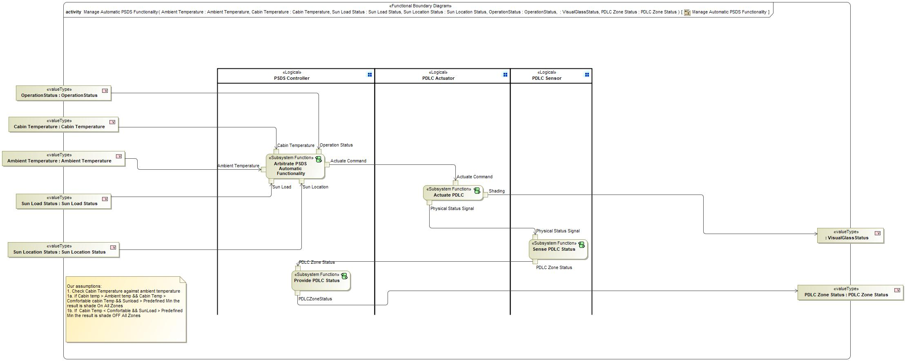

Figure 1: Activity Diagram of -1804989380.jpg “Manage Automatic PSDS Functionality” calling 645995023.jpg “Actuate PDLC”

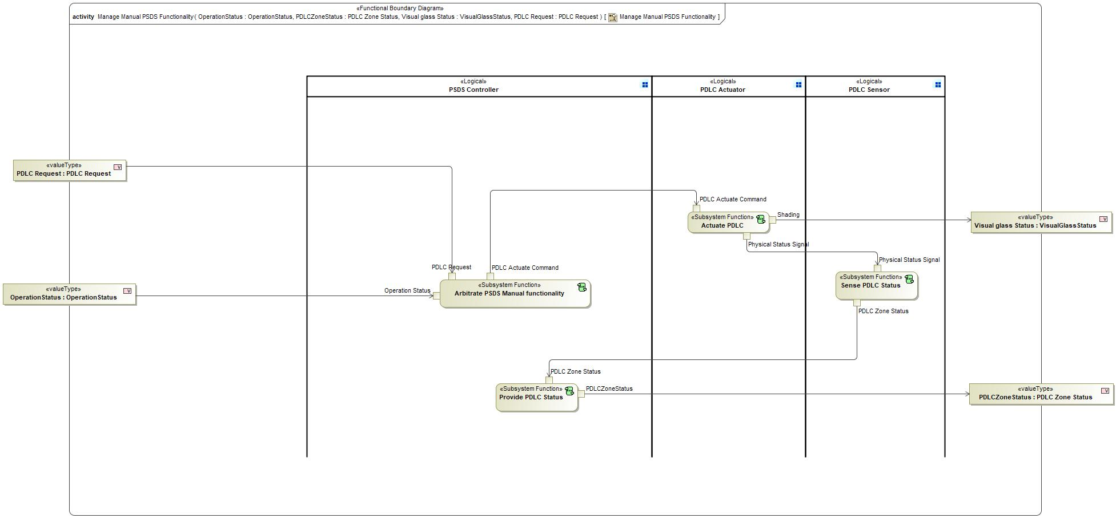

Figure 2: Activity Diagram of -1804989380.jpg “Manage Manual PSDS Functionality” calling 645995023.jpg “Actuate PDLC”

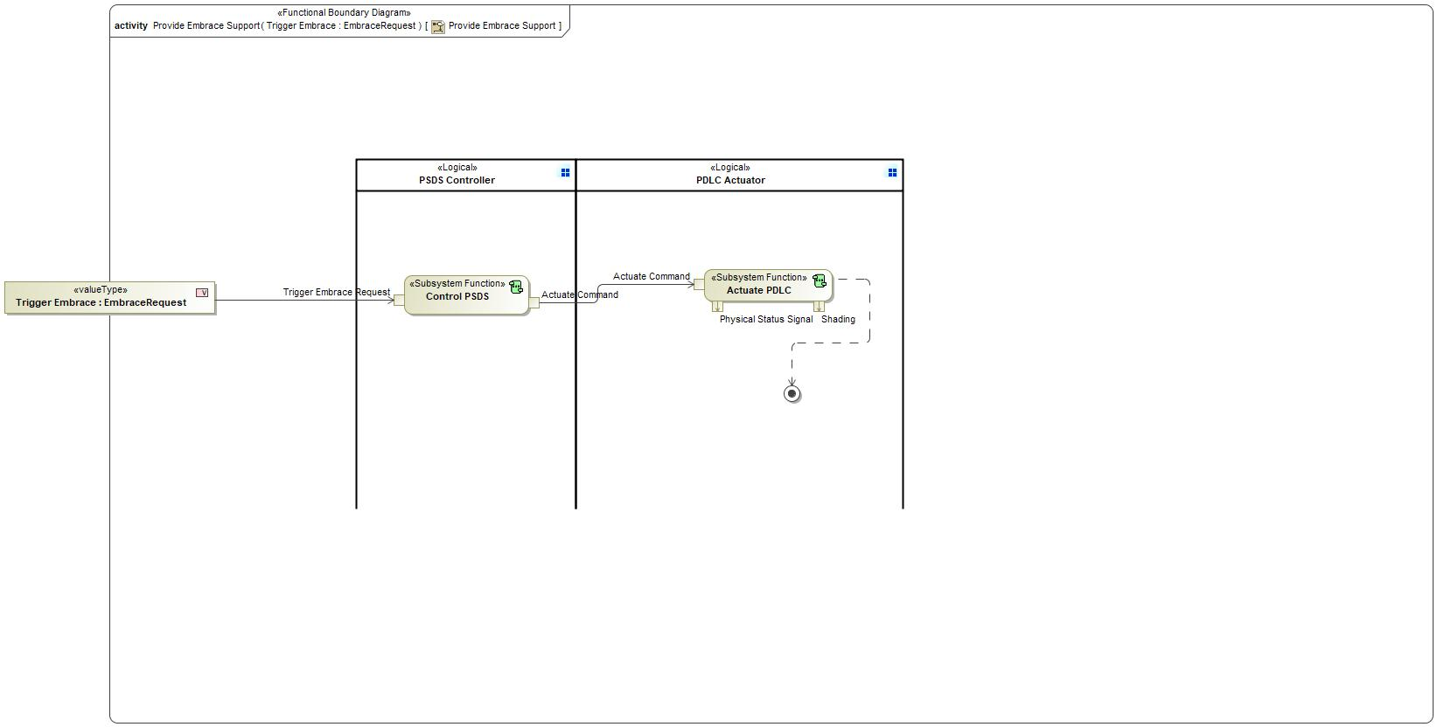

Figure 3: Activity Diagram of -1804989380.jpg “Provide Embrace Support” calling 645995023.jpg “Actuate PDLC”

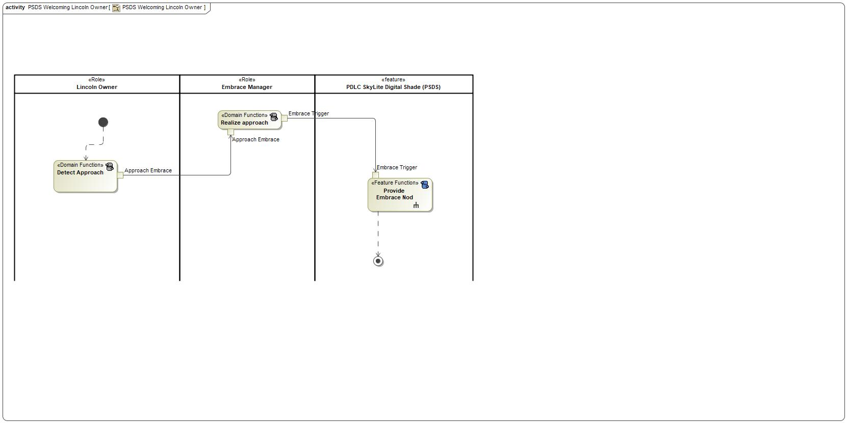

Figure 4: Activity Diagram of 120325397.jpg “PSDS Welcoming Lincoln Owner” calling 645995023.jpg “Actuate PDLC”

### Function Interfaces

**#Link:** [RE Wiki – Adding a Logical Signal or Parameter](http://wiki.ford.com/display/RequirementsEngineering/Adding+a+Logical+Signal+or+Parameter)

#### Logical Inputs

|  |  |
| --- | --- |
| **Signal Name** | **Description** |
| Actuate Command  Type:  372253817.jpg PDLC Actuate Command | Received from:   * 645995023.jpg Control PSDS * 645995023.jpg Arbitrate PSDS Automatic Functionality * 645995023.jpg Arbitrate PSDS Manual functionality |

#### Logical Outputs

|  |  |
| --- | --- |
| **Signal Name** | **Description** |
| Shading  Type:  372253817.jpg VisualGlassStatus | Sent to:   * 198874124.jpg Activity Parameter Node * 198874124.jpg Activity Parameter Node: Visual glass Status |
| Physical Status Signal  Type:  372253817.jpg PDLC Physical Measured Position | Sent to:   * 645995023.jpg Sense PDLC Status |

#### Logical Parameters

**#Hint**: Put requirements for parameters here, which are implemented as configuration parameters using Method 2 or 3 or as parameters for calibration.

*Not supported by MagicDraw report generation.*

### Function Modeling

**#Classification:** Mandatory

**#Hint:** Typical modeling artifacts in this section are State Machines, Activity Diagrams / Flow Charts, Decision Tables, and possibly Sequence Diagrams, which can all be used as techniques to analyze the function requirements.

**#Links:** Analyze / Model Requirements: [RE Wiki – Analyze / Model Requirements](http://wiki.ford.com/pages/viewpage.action?pageId=110594919&src=contextnavpagetreemode)

#### Use Cases

**#Classification:** Infotainment Only (remove section, if not used)

**#Hint:** Some Domains (e.g. Infotainment) use not only Customer Use Cases (in the Feature Doc), but refine Use Case descriptions down to function level. In general, the RE approach encourages the use of Use Cases on Feature Level but not on Function Level. Activity Diagrams are a more suitable way to express the same on Function Level.

**#Links:** Infotainment – “Harmony Systems Engineering” Approach

*Not supported by MagicDraw report generation.*

#### State Charts / Activity Diagrams / Sequence Diagrams / Decision Tables

**#Classification:** Mandatory

**#Hint:** It is highly recommended to use at least one of the following modeling techniques for modeling and analyzing the Function behavior and derived requirements (refer to sample diagrams below):

State Machines, Activity Diagrams / Flow Charts, or Decision Tables

Optionally, Sequence Diagrams might help to analyze the interaction between Functions.

**#Links:** Analyze / Model Requirements: [RE Wiki – Analyze / Model Requirements](http://wiki.ford.com/pages/viewpage.action?pageId=110594919&src=contextnavpagetreemode)

State Charts [RE Wiki – State Charts](http://wiki.ford.com/display/RequirementsEngineering/State+Charts?src=contextnavpagetreemode)

Activity Diagrams: [RE Wiki – Activity Diagram](http://wiki.ford.com/display/RequirementsEngineering/Activity+Diagram?src=contextnavpagetreemode), [SysML User Group – Activity Diagram Basics](https://pd3.spt.ford.com/sites/SystemsEngineering/SEC/sysml-teamsite/SysML%20Wiki/Activity%20Diagram%20Basics.aspx)

Sequence Diagrams: [RE Wiki – Sequence Chart](http://wiki.ford.com/display/RequirementsEngineering/Sequence+Chart?src=contextnavpagetreemode), [SysML User Group – Sequence Diagram Basics](https://pd3.spt.ford.com/sites/SystemsEngineering/SEC/sysml-teamsite/SysML%20Wiki/Sequence%20Diagram%20Basics.aspx)

No diagrams internal to function specified.

### Function Requirements

#Link: [*RE Wiki – How to write good requirements*](http://wiki.ford.com/display/RequirementsEngineering/How+to+write+better+requirements?src=contextnavpagetreemode)

#### Functional Requirements

***#Hint:*** *Please also consider specific situations like Initialization (Startup) and Deinitialization (Shutdown) apart from Normal Operation and Error Handling. E.g. a* state chart or activity diagram might help for better understanding.

##### Normal Operation

Actuate PDLC Zones Request

When the "Actuate PDLC" receives "PDLC Actuate Command" it shall output "PDLC Physical Measured Position" "VisualGlassStatus"

|  |  |  |  |  |  |  |  |
| --- | --- | --- | --- | --- | --- | --- | --- |
| Requirement ID: | | | | | | | |
| **Rationale** |  | | | | | | |
| **Acceptance Criteria** |  | | | | | | |
| **Notes** |  | | | | | | |
| **Source** |  | | | | | **Owner** |  |
| **Source Req.** |  | | | | | **V&V Method** |  |
| **Type** |  | | | **Priority** |  | **Status** |  |
| [Req. Template](http://wiki.ford.com/display/RequirementsEngineering/Requirements+Attributes) Version | | 6.0 | End of Requirement | | | | |

##### Error Handling

***#Hint:*** *FMEA counter measures could be considered as requirements in this chapter*

No Error Handling Requirements specified.

#### Non-Functional Requirements

***#Hint:*** *Non-functional requirements specify some performance criteria in addition to the functional behavior given defined by the functional requirements. Timing (if not already included in the functional requirements), security details (e.g. how secure does an algorithm have to be) or reliability (e.g. mean time between failure) could be specified in this section.*

No Non-Functional Requirements specified.

#### Functional Safety Requirements

**#Classification**: Functional Safety only – If not used, remove content and state “Not Applicable”

***#Hint:*** *Add Functional Safety Requirements (FSRs) derived for this function.*

**#Link:** [Functional Safety Sharepoint](https://pd3.spt.ford.com/sites/GlobalFunctionalSafety/Pages/default.aspx) – Functional Safety Concept

[RE Wiki - Requirements Attributes](http://wiki.ford.com/display/RequirementsEngineering/Requirements+Attributes)

No Functional Safety Requirements specified.

##### ASIL Decomposition of Functional Safety Requirements

**#Classification**: Functional Safety only – If not used, remove content and state “Not Applicable”

***#Hint:*** *Sometimes an ASIL decomposition of Functional Safety Requirements is required. The decomposed FSRs should be listed beneath each ASIL Decomposition table below and referenced inside the table by ID and Title*

**#Link:** [Functional Safety Sharepoint](https://pd3.spt.ford.com/sites/GlobalFunctionalSafety/Pages/default.aspx) – Functional Safety Concept

No Functional Safety Requirements with ASIL Decompositions specified.

#### Other Requirements

##### Design Requirements

***#Hint:*** *Requirements of a Logical Function should be typically agnostic of their SW/HW implementation*. If for specific reasons the function owner needs to define explicitly design constraints, it can be done in this chapter.

No Design Requirements specified.

## 645995023.jpg Analyze Operations

### Function Overview

#### Description

Function is allocated to:

* 1136159206.jpg Arbitrate PSDS Functionality <<Logical>>
* 1136159206.jpg Manage CAN communication <<Logical>>
* 1136159206.jpg Provide Crash Event Status <<Logical>>
* 1136159206.jpg Provide Vehicle Status <<Logical>>
* 879009790.jpg PSDS Controller <<Logical>>

No description provided for this function.

#### Variants

*Not supported by MagicDraw report generation.*

#### Input Requirements

*Not supported by MagicDraw report generation.*

#### Assumptions

No assumptions specified for this function.

#### References

##### Ford Documents

List here all Ford internal documents, which are directly related to the feature.

| **Reference** | **Title** | **Doc. ID** | **Revision** |
| --- | --- | --- | --- |
|  |  |  |  |

Table 5: Ford internal Documents *(not specified in model)*

##### External Documents and Publications

The list of external documents could include books, reports and online sources.

| **Reference** | **Document / Publication** |
| --- | --- |
|  |  |

Table 6: External documents and publications *(not specified in model)*

#### Glossary

See Appendix for Definitions and Abbreviations.

### Function Scope

The 645995023.jpg **– “Analyze Operations”** function is called by the following functions:

* -1804989380.jpg – “Check Operation Status”

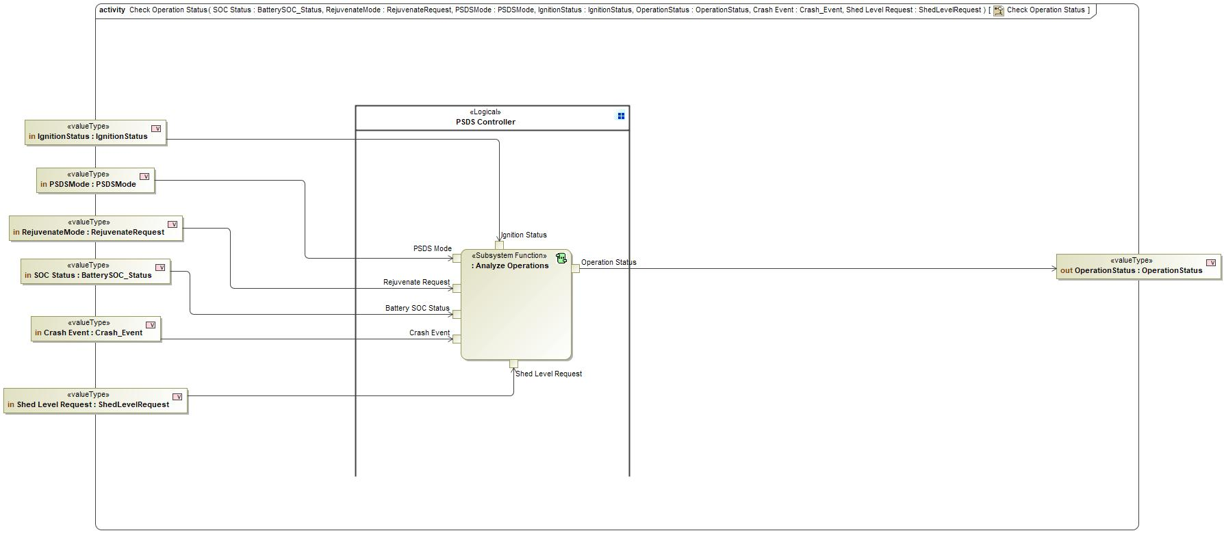

Figure 5: Activity Diagram of -1804989380.jpg “Check Operation Status” calling 645995023.jpg “Analyze Operations”

### Function Interfaces

#### Logical Inputs

|  |  |
| --- | --- |
| **Signal Name** | **Description** |
| Shed Level Request  Type:  372253817.jpg ShedLevelRequest | Received from:   * 198874124.jpg Activity Parameter Node: Shed Level Request |
| Ignition Status  Type:  372253817.jpg IgnitionStatus | Received from:   * 198874124.jpg Activity Parameter Node: IgnitionStatus |
| PSDS Mode  Type:  372253817.jpg PSDSMode | Received from:   * 198874124.jpg Activity Parameter Node: PSDSMode |
| Crash Event  Type:  372253817.jpg Crash_Event | Received from:   * 198874124.jpg Activity Parameter Node: Crash Event |
| Rejuvenate Request  Type:  372253817.jpg RejuvenateRequest | Received from:   * 198874124.jpg Activity Parameter Node: RejuvenateMode |
| Battery SOC Status  Type:  372253817.jpg BatterySOC_Status | Received from:   * 198874124.jpg Activity Parameter Node: SOC Status |

#### Logical Outputs

|  |  |
| --- | --- |
| **Signal Name** | **Description** |
| Operation Status  Type:  372253817.jpg OperationStatus | Sent to:   * 198874124.jpg Activity Parameter Node: OperationStatus |

#### Logical Parameters

*Not supported by MagicDraw report generation.*

### Function Modeling

#### Use Cases

*Not supported by MagicDraw report generation.*

#### State Charts / Activity Diagrams / Sequence Diagrams / Decision Tables

No diagrams internal to function specified.

### Function Requirements

#### Functional Requirements

##### Normal Operation

No Normal Operation Requirements specified.

##### Error Handling

No Error Handling Requirements specified.

#### Non-Functional Requirements

No Non-Functional Requirements specified.

#### Functional Safety Requirements

No Functional Safety Requirements specified.

##### ASIL Decomposition of Functional Safety Requirements

No Functional Safety Requirements with ASIL Decompositions specified.

#### Other Requirements

##### Design Requirements

No Design Requirements specified.

#### Uncategorized Requirements

Check Operation

When "Analyze Operations" receives "IgnitionStatus" "PSDSMode" "RejuvenateRequest" "BatterySOC_Status" "Crash_Event" "ShedLevelRequest" it shall output "OperationStatus"

|  |  |  |  |  |  |  |  |
| --- | --- | --- | --- | --- | --- | --- | --- |
| Requirement ID: | | | | | | | |
| **Rationale** |  | | | | | | |
| **Acceptance Criteria** |  | | | | | | |
| **Notes** |  | | | | | | |
| **Source** |  | | | | | **Owner** |  |
| **Source Req.** |  | | | | | **V&V Method** |  |
| **Type** |  | | | **Priority** |  | **Status** |  |
| [Req. Template](http://wiki.ford.com/display/RequirementsEngineering/Requirements+Attributes) Version | | 6.0 | End of Requirement | | | | |

## 645995023.jpg Arbitrate PSDS Automatic Functionality

### Function Overview

#### Description

Function is allocated to:

* 1136159206.jpg Arbitrate PSDS Functionality <<Logical>>
* 1136159206.jpg Provide Sunload <<Logical>>
* 1136159206.jpg Provide Temperature <<Logical>>
* 879009790.jpg PSDS Controller <<Logical>>
* 1136159206.jpg Select the PSDS Functionality <<Logical>>
* 1136159206.jpg Support Rejuvenate <<Logical>>

No description provided for this function.

#### Variants

*Not supported by MagicDraw report generation.*

#### Input Requirements

*Not supported by MagicDraw report generation.*

#### Assumptions

No assumptions specified for this function.

#### References

##### Ford Documents

List here all Ford internal documents, which are directly related to the feature.

| **Reference** | **Title** | **Doc. ID** | **Revision** |
| --- | --- | --- | --- |
|  |  |  |  |

Table 7: Ford internal Documents *(not specified in model)*

##### External Documents and Publications

The list of external documents could include books, reports and online sources.

| **Reference** | **Document / Publication** |
| --- | --- |
|  |  |

Table 8: External documents and publications *(not specified in model)*

#### Glossary

See Appendix for Definitions and Abbreviations.

### Function Scope

The 645995023.jpg **– “Arbitrate PSDS Automatic Functionality”** function is called by the following functions:

* -1804989380.jpg – “Manage Automatic PSDS Functionality”



Figure 6: Activity Diagram of -1804989380.jpg “Manage Automatic PSDS Functionality” calling 645995023.jpg “Arbitrate PSDS Automatic Functionality”

### Function Interfaces

#### Logical Inputs

|  |  |
| --- | --- |
| **Signal Name** | **Description** |
| Operation Status  Type:  372253817.jpg OperationStatus | Received from:   * 198874124.jpg Activity Parameter Node: OperationStatus |
| Sun Load  Type:  372253817.jpg Sun Load Status | Received from:   * 198874124.jpg Activity Parameter Node: Sun Load Status |
| Cabin Temperature  Type:  372253817.jpg Cabin Temperature | Received from:   * 198874124.jpg Activity Parameter Node: Cabin Temperature |
| Ambient Temperature  Type:  372253817.jpg Ambient Temperature | Received from:   * 198874124.jpg Activity Parameter Node: Ambient Temperature |
| Sun Location  Type:  372253817.jpg Sun Location Status | Received from:   * 198874124.jpg Activity Parameter Node: Sun Location Status |

#### Logical Outputs

|  |  |
| --- | --- |
| **Signal Name** | **Description** |
| Actuate Command  Type:  372253817.jpg PDLC Actuate Command | Sent to:   * 645995023.jpg Actuate PDLC |

#### Logical Parameters

*Not supported by MagicDraw report generation.*

### Function Modeling

#### Use Cases

*Not supported by MagicDraw report generation.*

#### State Charts / Activity Diagrams / Sequence Diagrams / Decision Tables

No diagrams internal to function specified.

### Function Requirements

#### Functional Requirements

##### Normal Operation

No Normal Operation Requirements specified.

##### Error Handling

No Error Handling Requirements specified.

#### Non-Functional Requirements

No Non-Functional Requirements specified.

#### Functional Safety Requirements

No Functional Safety Requirements specified.

##### ASIL Decomposition of Functional Safety Requirements

No Functional Safety Requirements with ASIL Decompositions specified.

#### Other Requirements

##### Design Requirements

No Design Requirements specified.

#### Uncategorized Requirements

Arbitrate PSDS Automatic Mode

When "Arbitrate PSDS Automatic functionality" receives "OperationStatus" "Cabin Temperature" "Ambient Temperature" "Sun Load Status" " it shall:

1. Verify that IgnitionStatus~=ENGINE_OFF and BatterySOC_Status=NORMAL

2. Verify that RejuvenateRequest=NONE

3. Verify that Shed_Level_Req = normal

4.Verify that Crash_Event = Normal

5. Verify Cabin temp > Ambient temp

6. Verify Cabin Temp > Comfortable cabin Temp

7.Verify Sunload > Predefined Minimum

8. Set PSDS Status::OperationStatus=AUTOMATIC_MODE_ACTIVE

It shall output "PDLC Actuate Command"

|  |  |  |  |  |  |  |  |
| --- | --- | --- | --- | --- | --- | --- | --- |
| Requirement ID: | | | | | | | |
| **Rationale** |  | | | | | | |
| **Acceptance Criteria** |  | | | | | | |
| **Notes** |  | | | | | | |
| **Source** |  | | | | | **Owner** |  |
| **Source Req.** |  | | | | | **V&V Method** |  |
| **Type** |  | | | **Priority** |  | **Status** |  |
| [Req. Template](http://wiki.ford.com/display/RequirementsEngineering/Requirements+Attributes) Version | | 6.0 | End of Requirement | | | | |

## 645995023.jpg Arbitrate PSDS Manual functionality

### Function Overview

#### Description

Function is allocated to:

* 1136159206.jpg Arbitrate PSDS Functionality <<Logical>>
* 879009790.jpg PSDS Controller <<Logical>>
* 1136159206.jpg Select the PSDS Functionality <<Logical>>
* 1136159206.jpg Support Rejuvenate <<Logical>>

No description provided for this function.

#### Variants

*Not supported by MagicDraw report generation.*

#### Input Requirements

*Not supported by MagicDraw report generation.*

#### Assumptions

No assumptions specified for this function.

#### References

##### Ford Documents

List here all Ford internal documents, which are directly related to the feature.

| **Reference** | **Title** | **Doc. ID** | **Revision** |
| --- | --- | --- | --- |
|  |  |  |  |

Table 9: Ford internal Documents *(not specified in model)*

##### External Documents and Publications

The list of external documents could include books, reports and online sources.

| **Reference** | **Document / Publication** |
| --- | --- |
|  |  |

Table 10: External documents and publications *(not specified in model)*

#### Glossary

See Appendix for Definitions and Abbreviations.

### Function Scope

The 645995023.jpg **– “Arbitrate PSDS Manual functionality”** function is called by the following functions:

* -1804989380.jpg – “Manage Manual PSDS Functionality”



Figure 7: Activity Diagram of -1804989380.jpg “Manage Manual PSDS Functionality” calling 645995023.jpg “Arbitrate PSDS Manual functionality”

### Function Interfaces

#### Logical Inputs

|  |  |
| --- | --- |
| **Signal Name** | **Description** |
| PDLC Request  Type:  372253817.jpg PDLC Request | Received from:   * 198874124.jpg Activity Parameter Node: PDLC Request |
| Operation Status  Type:  372253817.jpg OperationStatus | Received from:   * 198874124.jpg Activity Parameter Node: OperationStatus |

#### Logical Outputs

|  |  |
| --- | --- |
| **Signal Name** | **Description** |
| PDLC Actuate Command  Type:  372253817.jpg PDLC Actuate Command | Sent to:   * 645995023.jpg Actuate PDLC |

#### Logical Parameters

*Not supported by MagicDraw report generation.*

### Function Modeling

#### Use Cases

*Not supported by MagicDraw report generation.*

#### State Charts / Activity Diagrams / Sequence Diagrams / Decision Tables

No diagrams internal to function specified.

### Function Requirements

#### Functional Requirements

##### Normal Operation

No Normal Operation Requirements specified.

##### Error Handling

No Error Handling Requirements specified.

#### Non-Functional Requirements

No Non-Functional Requirements specified.

#### Functional Safety Requirements

No Functional Safety Requirements specified.

##### ASIL Decomposition of Functional Safety Requirements

No Functional Safety Requirements with ASIL Decompositions specified.

#### Other Requirements

##### Design Requirements

No Design Requirements specified.

#### Uncategorized Requirements

Arbitrate PSDS Manual Mode

When "Arbitrate PSDS Manual functionality" receives "OperationStatus" "PDLC Request" it shall:

1. Verify that IgnitionStatus~=ENGINE_OFF and BatterySOC_Status=NORMAL

2. Verify that RejuvenateRequest=NONE

3. Verify that Shed_Level_Req = normal

4.Verify that Crash_Event = Normal

5. Set PSDS Status::OperationStatus=MANUAL_MODE_ACTIVE

It shall output "PDLC Actuate Command"

|  |  |  |  |  |  |  |  |
| --- | --- | --- | --- | --- | --- | --- | --- |
| Requirement ID: | | | | | | | |
| **Rationale** |  | | | | | | |
| **Acceptance Criteria** |  | | | | | | |
| **Notes** |  | | | | | | |
| **Source** |  | | | | | **Owner** |  |
| **Source Req.** |  | | | | | **V&V Method** |  |
| **Type** |  | | | **Priority** |  | **Status** |  |
| [Req. Template](http://wiki.ford.com/display/RequirementsEngineering/Requirements+Attributes) Version | | 6.0 | End of Requirement | | | | |

## -1804989380.jpg Check Operation Status

### Function Overview

#### Description

Function is allocated to:

* 879009790.jpg PSDS System <<Logical>>

No description provided for this function.

#### Variants

*Not supported by MagicDraw report generation.*

#### Input Requirements

*Not supported by MagicDraw report generation.*

#### Assumptions

No assumptions specified for this function.

#### References

##### Ford Documents

List here all Ford internal documents, which are directly related to the feature.

| **Reference** | **Title** | **Doc. ID** | **Revision** |
| --- | --- | --- | --- |
|  |  |  |  |

Table 11: Ford internal Documents *(not specified in model)*

##### External Documents and Publications

The list of external documents could include books, reports and online sources.

| **Reference** | **Document / Publication** |
| --- | --- |
|  |  |

Table 12: External documents and publications *(not specified in model)*

#### Glossary

See Appendix for Definitions and Abbreviations.

### Function Scope

The -1804989380.jpg **– “Check Operation Status”** function is called by the following functions:

* -2053456283.jpg – “Request automatic PSDS actuation”
* -2053456283.jpg – “Request PSDS Manual Actuation”

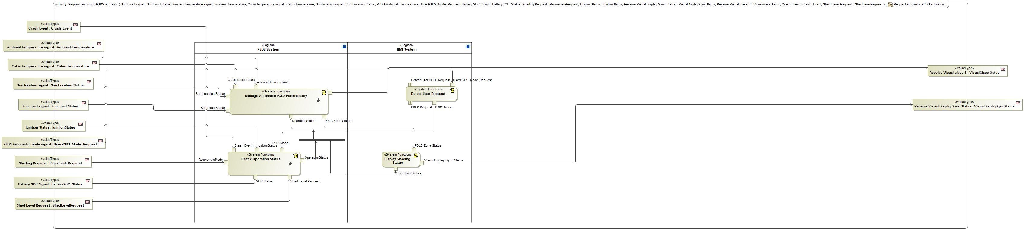

Figure 8: Activity Diagram of -830053584.jpg “Request automatic PSDS actuation” calling 1864100599.jpg “Check Operation Status”

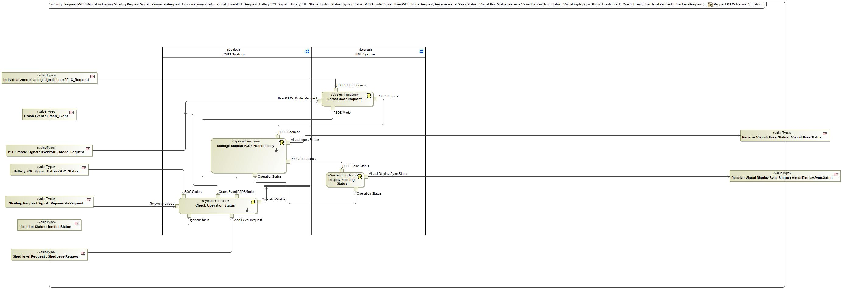

Figure 9: Activity Diagram of -830053584.jpg “Request PSDS Manual Actuation” calling 1864100599.jpg “Check Operation Status”

### Function Interfaces

#### Logical Inputs

|  |  |
| --- | --- |
| **Signal Name** | **Description** |
| SOC Status  Type:  746038487.jpg BatterySOC_Status | Received from:   * 198874124.jpg Activity Parameter Node: Battery SOC Signal * 198874124.jpg Activity Parameter Node: vehicle ON |
| Crash Event  Type:  746038487.jpg Crash_Event | Received from:   * 198874124.jpg Activity Parameter Node: Crash Event * 198874124.jpg Activity Parameter Node: Crash Event |
| IgnitionStatus  Type:  746038487.jpg IgnitionStatus | Received from:   * 198874124.jpg Activity Parameter Node: Ignition Status * 198874124.jpg Activity Parameter Node: Ignition Status |
| RejuvenateMode  Type:  746038487.jpg RejuvenateRequest | Received from:   * 198874124.jpg Activity Parameter Node: Shading Request Signa * 198874124.jpg Activity Parameter Node: Sun Load signal |
| Shed Level Request  Type:  746038487.jpg ShedLevelRequest | Received from:   * 198874124.jpg Activity Parameter Node: Shed level Request * 198874124.jpg Activity Parameter Node: Shed Level Request |
| PSDSMode  Type:  746038487.jpg PSDSMode | Received from:   * 1864100599.jpg Detect User Request |

#### Logical Outputs

|  |  |
| --- | --- |
| **Signal Name** | **Description** |
| OperationStatus  Type:  746038487.jpg OperationStatus | Sent to:   * 1864100599.jpg Manage Automatic PSDS Functionality * 1864100599.jpg Display Shading Status * 1864100599.jpg Manage Manual PSDS Functionality |

#### Logical Parameters

*Not supported by MagicDraw report generation.*

### Function Modeling

#### Use Cases

*Not supported by MagicDraw report generation.*

#### State Charts / Activity Diagrams / Sequence Diagrams / Decision Tables



Figure 10: Check Operation Status

### Function Requirements

#### Functional Requirements

##### Normal Operation

Check Rejuvenate Mode OFF

When the "Check Operation Status" receives the trigger RejuvenateRequest=REJUVENATE_OFF it shall:

1. Set PSDS Status::OperationStatus=REJUVENATE_MODE_INACTIVE

|  |  |  |  |  |  |  |  |
| --- | --- | --- | --- | --- | --- | --- | --- |
| Requirement ID: | | | | | | | |
| **Rationale** |  | | | | | | |
| **Acceptance Criteria** |  | | | | | | |
| **Notes** |  | | | | | | |
| **Source** |  | | | | | **Owner** |  |
| **Source Req.** | * -145572143.jpg PSDS Rejuvenate * -145572143.jpg PSDS integrated features | | | | | **V&V Method** |  |
| **Type** |  | | | **Priority** |  | **Status** |  |
| [Req. Template](http://wiki.ford.com/display/RequirementsEngineering/Requirements+Attributes) Version | | 6.0 | End of Requirement | | | | |

Check Manual Mode ON

When the "Check Operation Status" receives the trigger PSDSMode = PSDS_MANUAL it shall:

1. Verify that IgnitionStatus~=ENGINE_OFF and BatterySOC_Status=NORMAL

2. Verify that RejuvenateRequest=NONE

3. Set PSDS Status::OperationStatus=MANUAL_MODE_ACTIVE

|  |  |  |  |  |  |  |  |
| --- | --- | --- | --- | --- | --- | --- | --- |
| Requirement ID: | | | | | | | |
| **Rationale** |  | | | | | | |
| **Acceptance Criteria** |  | | | | | | |
| **Notes** |  | | | | | | |
| **Source** |  | | | | | **Owner** |  |
| **Source Req.** | * -145572143.jpg PSDS power output | | | | | **V&V Method** |  |
| **Type** |  | | | **Priority** |  | **Status** |  |
| [Req. Template](http://wiki.ford.com/display/RequirementsEngineering/Requirements+Attributes) Version | | 6.0 | End of Requirement | | | | |

Check Automatic Mode ON

When the "Check Operation Status" receives the trigger PSDSMode = PSDS_AUTOMATIC it shall:

1. Verify that IgnitionStatus~=ENGINE_OFF and BatterySOC_Status=NORMAL

2. Verify that RejuvenateRequest=NONE

3. Set PSDS Status::OperationStatus=AUTOMATIC_MODE_ACTIVE

|  |  |  |  |  |  |  |  |
| --- | --- | --- | --- | --- | --- | --- | --- |
| Requirement ID: | | | | | | | |
| **Rationale** |  | | | | | | |
| **Acceptance Criteria** |  | | | | | | |
| **Notes** |  | | | | | | |
| **Source** |  | | | | | **Owner** |  |
| **Source Req.** | * -145572143.jpg PSDS power output | | | | | **V&V Method** |  |
| **Type** |  | | | **Priority** |  | **Status** |  |
| [Req. Template](http://wiki.ford.com/display/RequirementsEngineering/Requirements+Attributes) Version | | 6.0 | End of Requirement | | | | |

Check Rejuvenate Mode ON

When the "Check Operation Status" receives the trigger RejuvenateRequest=REJUVENATE_ON it shall:

1. Verify that IgnitionStatus~=ENGINE_OFF and BatterySOC_Status=NORMAL

2. Set PSDS Status::OperationStatus=REJUVENATE_MODE_ACTIVE

|  |  |  |  |  |  |  |  |
| --- | --- | --- | --- | --- | --- | --- | --- |
| Requirement ID: | | | | | | | |
| **Rationale** |  | | | | | | |
| **Acceptance Criteria** |  | | | | | | |
| **Notes** |  | | | | | | |
| **Source** |  | | | | | **Owner** |  |
| **Source Req.** | * -145572143.jpg PSDS Rejuvenate * -145572143.jpg PSDS integrated features | | | | | **V&V Method** |  |
| **Type** |  | | | **Priority** |  | **Status** |  |
| [Req. Template](http://wiki.ford.com/display/RequirementsEngineering/Requirements+Attributes) Version | | 6.0 | End of Requirement | | | | |

Report Invalid PSDS Operation Conditions

If " Check Operation Status " is triggered through RejuvenateRequest or PDLC Request, it shall:

1. Set PSDS Status::OperationStatus= Ignition OFF if the input IgnitionStatus=ENGINE_OFF

2. Set PSDS Status::OperationStatus= SOC_LOW if the input BatterySOC_Status~=NORMAL

|  |  |  |  |  |  |  |  |
| --- | --- | --- | --- | --- | --- | --- | --- |
| Requirement ID: | | | | | | | |
| **Rationale** |  | | | | | | |
| **Acceptance Criteria** |  | | | | | | |
| **Notes** |  | | | | | | |
| **Source** |  | | | | | **Owner** |  |
| **Source Req.** | * -145572143.jpg PSDS signal output | | | | | **V&V Method** |  |
| **Type** |  | | | **Priority** |  | **Status** |  |
| [Req. Template](http://wiki.ford.com/display/RequirementsEngineering/Requirements+Attributes) Version | | 6.0 | End of Requirement | | | | |

##### Error Handling

No Error Handling Requirements specified.

#### Non-Functional Requirements

No Non-Functional Requirements specified.

#### Functional Safety Requirements

No Functional Safety Requirements specified.

##### ASIL Decomposition of Functional Safety Requirements

No Functional Safety Requirements with ASIL Decompositions specified.

#### Other Requirements

##### Design Requirements

No Design Requirements specified.

#### Uncategorized Requirements

Check Operations

When "Check Operation Status" receives "RejuvenateRequest" "Crash_Event" "IgnitionStatus" "PSDSMode" "BatterySOC_Status" "ShedLevelRequest" it shall output "OperationStatus"

|  |  |  |  |  |  |  |  |
| --- | --- | --- | --- | --- | --- | --- | --- |
| Requirement ID: | | | | | | | |
| **Rationale** |  | | | | | | |
| **Acceptance Criteria** |  | | | | | | |
| **Notes** |  | | | | | | |
| **Source** |  | | | | | **Owner** |  |
| **Source Req.** | * -145572143.jpg PSDS signal input * -145572143.jpg PDLC sleep * -145572143.jpg PSDS integrated features * -145572143.jpg PSDS power output | | | | | **V&V Method** |  |
| **Type** |  | | | **Priority** |  | **Status** |  |
| [Req. Template](http://wiki.ford.com/display/RequirementsEngineering/Requirements+Attributes) Version | | 6.0 | End of Requirement | | | | |

## -588598805.jpg Control PSDS

### Function Overview

#### Description

Function is allocated to:

* 928225610.jpg PSDS Controller <<Logical>>
* -1034039988.jpg Request Shade through climate <<Logical>>
* -1034039988.jpg Support Embrace <<Logical>>

No description provided for this function.

#### Variants

*Not supported by MagicDraw report generation.*

#### Input Requirements

*Not supported by MagicDraw report generation.*

#### Assumptions

No assumptions specified for this function.

#### References

##### Ford Documents

List here all Ford internal documents, which are directly related to the feature.

| **Reference** | **Title** | **Doc. ID** | **Revision** |
| --- | --- | --- | --- |
|  |  |  |  |

Table 13: Ford internal Documents *(not specified in model)*

##### External Documents and Publications

The list of external documents could include books, reports and online sources.

| **Reference** | **Document / Publication** |
| --- | --- |
|  |  |

Table 14: External documents and publications *(not specified in model)*

#### Glossary

See Appendix for Definitions and Abbreviations.

### Function Scope

The -588598805.jpg **– “Control PSDS”** function is called by the following functions:

* 1864100599.jpg – “Provide Embrace Support”
* 120325397.jpg – “PSDS Welcoming Lincoln Owner”



Figure 11: Activity Diagram of 1864100599.jpg “Provide Embrace Support” calling -588598805.jpg “Control PSDS”



Figure 12: Activity Diagram of 120325397.jpg “PSDS Welcoming Lincoln Owner” calling -588598805.jpg “Control PSDS”

### Function Interfaces

#### Logical Inputs

|  |  |
| --- | --- |
| **Signal Name** | **Description** |
| Trigger Embrace Request  Type:  746038487.jpg EmbraceRequest | Received from:   * 198874124.jpg Activity Parameter Node: Trigger Embrace |

#### Logical Outputs

|  |  |
| --- | --- |
| **Signal Name** | **Description** |
| Actuate Command  Type:  746038487.jpg PDLC Actuate Command | Sent to:   * -588598805.jpg Actuate PDLC |

#### Logical Parameters

*Not supported by MagicDraw report generation.*

### Function Modeling

#### Use Cases

*Not supported by MagicDraw report generation.*

#### State Charts / Activity Diagrams / Sequence Diagrams / Decision Tables

No diagrams internal to function specified.

### Function Requirements

#### Functional Requirements

##### Normal Operation

Control Embrace Request

When the "Control PSDS" receives the trigger EmbraceRequest= EMBRACE_APPROACH it shall Request Actuate PDLC:: PDLC Actuate Command=Actuate ALL Zones=ON

|  |  |  |  |  |  |  |  |
| --- | --- | --- | --- | --- | --- | --- | --- |
| Requirement ID: | | | | | | | |
| **Rationale** |  | | | | | | |
| **Acceptance Criteria** |  | | | | | | |
| **Notes** |  | | | | | | |
| **Source** |  | | | | | **Owner** |  |
| **Source Req.** |  | | | | | **V&V Method** |  |
| **Type** |  | | | **Priority** |  | **Status** |  |
| [Req. Template](http://wiki.ford.com/display/RequirementsEngineering/Requirements+Attributes) Version | | 6.0 | End of Requirement | | | | |

Control Embrace Depart Request

When the "Control PSDS" receives the trigger EmbraceRequest=EMBRACE_DEPART it shall Request Actuate PDLC:: PDLC Actuate Command=Actuate ALL Zones=OFF

|  |  |  |  |  |  |  |  |
| --- | --- | --- | --- | --- | --- | --- | --- |
| Requirement ID: | | | | | | | |
| **Rationale** |  | | | | | | |
| **Acceptance Criteria** |  | | | | | | |
| **Notes** |  | | | | | | |
| **Source** |  | | | | | **Owner** |  |
| **Source Req.** |  | | | | | **V&V Method** |  |
| **Type** |  | | | **Priority** |  | **Status** |  |
| [Req. Template](http://wiki.ford.com/display/RequirementsEngineering/Requirements+Attributes) Version | | 6.0 | End of Requirement | | | | |

##### Error Handling

No Error Handling Requirements specified.

#### Non-Functional Requirements

No Non-Functional Requirements specified.

#### Functional Safety Requirements

No Functional Safety Requirements specified.

##### ASIL Decomposition of Functional Safety Requirements

No Functional Safety Requirements with ASIL Decompositions specified.

#### Other Requirements

##### Design Requirements

No Design Requirements specified.

## 1864100599.jpg Manage Automatic PSDS Functionality

### Function Overview

#### Description

Function is allocated to:

* 928225610.jpg PSDS System <<Logical>>

No description provided for this function.

#### Variants

*Not supported by MagicDraw report generation.*

#### Input Requirements

*Not supported by MagicDraw report generation.*

#### Assumptions

No assumptions specified for this function.

#### References

##### Ford Documents

List here all Ford internal documents, which are directly related to the feature.

| **Reference** | **Title** | **Doc. ID** | **Revision** |
| --- | --- | --- | --- |
|  |  |  |  |

Table 15: Ford internal Documents *(not specified in model)*

##### External Documents and Publications

The list of external documents could include books, reports and online sources.

| **Reference** | **Document / Publication** |
| --- | --- |
|  |  |

Table 16: External documents and publications *(not specified in model)*

#### Glossary

See Appendix for Definitions and Abbreviations.

### Function Scope

The 1864100599.jpg **– “Manage Automatic PSDS Functionality”** function is called by the following functions:

* -830053584.jpg – “Request automatic PSDS actuation”



Figure 13: Activity Diagram of -830053584.jpg “Request automatic PSDS actuation” calling 1864100599.jpg “Manage Automatic PSDS Functionality”

### Function Interfaces

#### Logical Inputs

|  |  |
| --- | --- |
| **Signal Name** | **Description** |
| Sun Load Status  Type:  746038487.jpg Sun Load Status | Received from:   * 198874124.jpg Activity Parameter Node: Sun Load signal |
| Sun Location Status  Type:  746038487.jpg Sun Location Status | Received from:   * 198874124.jpg Activity Parameter Node: Sun location signal |
| Cabin Temperature  Type:  746038487.jpg Cabin Temperature | Received from:   * 198874124.jpg Activity Parameter Node: Cabin temperature signal |
| OperationStatus  Type:  746038487.jpg OperationStatus | Received from:   * 1864100599.jpg Check Operation Status |
| Ambient Temperature  Type:  746038487.jpg Ambient Temperature | Received from:   * 198874124.jpg Activity Parameter Node: Ambient temperature signal |

#### Logical Outputs

|  |  |
| --- | --- |
| **Signal Name** | **Description** |
| PDLC Zone Status  Type:  746038487.jpg PDLC Zone Status | Sent to:   * 1864100599.jpg Display Shading Status |
| Type:  746038487.jpg VisualGlassStatus | Sent to:   * 198874124.jpg Activity Parameter Node: Receive Visual glass S |

#### Logical Parameters

*Not supported by MagicDraw report generation.*

### Function Modeling

#### Use Cases

*Not supported by MagicDraw report generation.*

#### State Charts / Activity Diagrams / Sequence Diagrams / Decision Tables



Figure 14: Manage Automatic PSDS Functionality

### Function Requirements

#### Functional Requirements

##### Normal Operation

Support Automatic Request

When the "Manage Automatic PSDS Funtionality" receives the trigger PSDSMode= PSDS_Automatic it shall:

1. Verify that IgnitionStatus~=ENGINE_OFF and BatterySOC_Status=NORMAL

2. Verify that RejuvenateRequest~=REJUVENATE_OFF

3. Set PSDS Status::OperationStatus=AUTOMATIC_MODE_ACTIVE

|  |  |  |  |  |  |  |  |
| --- | --- | --- | --- | --- | --- | --- | --- |
| Requirement ID: | | | | | | | |
| **Rationale** |  | | | | | | |
| **Acceptance Criteria** |  | | | | | | |
| **Notes** |  | | | | | | |
| **Source** |  | | | | | **Owner** |  |
| **Source Req.** | * -145572143.jpg PSDS environment * -145572143.jpg PDLC translucent * -145572143.jpg PDLC opaque | | | | | **V&V Method** |  |
| **Type** |  | | | **Priority** |  | **Status** |  |
| [Req. Template](http://wiki.ford.com/display/RequirementsEngineering/Requirements+Attributes) Version | | 6.0 | End of Requirement | | | | |

##### Error Handling

No Error Handling Requirements specified.

#### Non-Functional Requirements

No Non-Functional Requirements specified.

#### Functional Safety Requirements

No Functional Safety Requirements specified.

##### ASIL Decomposition of Functional Safety Requirements

No Functional Safety Requirements with ASIL Decompositions specified.

#### Other Requirements

##### Design Requirements

No Design Requirements specified.

#### Uncategorized Requirements

Mange Automatic PSDS Mode

When "Manage Automatic PSDS Functionality" receives "OperationStatus" "Sun Load Status" "Sun Location Status" "Cabin Temperature" "Ambient Temperature" it shall output "VisualGlassStatus" and "PDLC Zone Status"

|  |  |  |  |  |  |  |  |
| --- | --- | --- | --- | --- | --- | --- | --- |
| Requirement ID: | | | | | | | |
| **Rationale** |  | | | | | | |
| **Acceptance Criteria** |  | | | | | | |
| **Notes** |  | | | | | | |
| **Source** |  | | | | | **Owner** |  |
| **Source Req.** | * -145572143.jpg PSDS signal input * -145572143.jpg PSDS environment * -145572143.jpg PDLC translucent * -145572143.jpg PSDS signal output * -145572143.jpg PDLC opaque | | | | | **V&V Method** |  |
| **Type** |  | | | **Priority** |  | **Status** |  |
| [Req. Template](http://wiki.ford.com/display/RequirementsEngineering/Requirements+Attributes) Version | | 6.0 | End of Requirement | | | | |

## 1864100599.jpg Manage Manual PSDS Functionality

### Function Overview

#### Description

Function is allocated to:

* 928225610.jpg PSDS System <<Logical>>

No description provided for this function.

#### Variants

*Not supported by MagicDraw report generation.*

#### Input Requirements

*Not supported by MagicDraw report generation.*

#### Assumptions

No assumptions specified for this function.

#### References

##### Ford Documents

List here all Ford internal documents, which are directly related to the feature.

| **Reference** | **Title** | **Doc. ID** | **Revision** |
| --- | --- | --- | --- |
|  |  |  |  |

Table 17: Ford internal Documents *(not specified in model)*

##### External Documents and Publications

The list of external documents could include books, reports and online sources.

| **Reference** | **Document / Publication** |
| --- | --- |
|  |  |

Table 18: External documents and publications *(not specified in model)*

#### Glossary

See Appendix for Definitions and Abbreviations.

### Function Scope

The 1864100599.jpg **– “Manage Manual PSDS Functionality”** function is called by the following functions:

* -830053584.jpg – “Request PSDS Manual Actuation”



Figure 15: Activity Diagram of -830053584.jpg “Request PSDS Manual Actuation” calling 1864100599.jpg “Manage Manual PSDS Functionality”

### Function Interfaces

#### Logical Inputs

|  |  |
| --- | --- |
| **Signal Name** | **Description** |
| PDLC Request  Type:  746038487.jpg PDLC Request | Received from:   * 1864100599.jpg Detect User Request |
| OperationStatus  Type:  746038487.jpg OperationStatus | Received from:   * 1864100599.jpg Check Operation Status |

#### Logical Outputs

|  |  |
| --- | --- |
| **Signal Name** | **Description** |
| PDLCZoneStatus  Type:  746038487.jpg PDLC Zone Status | Sent to:   * 1864100599.jpg Display Shading Status |
| Visual glass Status  Type:  746038487.jpg VisualGlassStatus | Sent to:   * 198874124.jpg Activity Parameter Node: Receive Visual Glass Status |

#### Logical Parameters

*Not supported by MagicDraw report generation.*

### Function Modeling

#### Use Cases

*Not supported by MagicDraw report generation.*

#### State Charts / Activity Diagrams / Sequence Diagrams / Decision Tables



Figure 16: Manage Manual PSDS Functionality

### Function Requirements

#### Functional Requirements

##### Normal Operation

Support Manual Request

When the "Manage PSDS Funtionality" receives the trigger PDLC Request= RequestZones(1-6) it shall:

1. Verify that IgnitionStatus~=ENGINE_OFF and BatterySOC_Status=NORMAL

2. Verify that RejuvenateRequest~=REJUVENATE_ON

3. Verify that PSDSMode=PSDS_MANUAL

4. Set PSDS Status::OperationStatus=MANUAL_MODE_ACTIVE

5.Set PSDS Status::PDLC Zone Status::Zone(1-6)Status=ON

|  |  |  |  |  |  |  |  |
| --- | --- | --- | --- | --- | --- | --- | --- |
| Requirement ID: | | | | | | | |
| **Rationale** |  | | | | | | |
| **Acceptance Criteria** |  | | | | | | |
| **Notes** |  | | | | | | |
| **Source** |  | | | | | **Owner** |  |
| **Source Req.** | * -145572143.jpg PDLC translucent * -145572143.jpg PDLC opaque | | | | | **V&V Method** |  |
| **Type** |  | | | **Priority** |  | **Status** |  |
| [Req. Template](http://wiki.ford.com/display/RequirementsEngineering/Requirements+Attributes) Version | | 6.0 | End of Requirement | | | | |

##### Error Handling

No Error Handling Requirements specified.

#### Non-Functional Requirements

No Non-Functional Requirements specified.

#### Functional Safety Requirements

No Functional Safety Requirements specified.

##### ASIL Decomposition of Functional Safety Requirements

No Functional Safety Requirements with ASIL Decompositions specified.

#### Other Requirements

##### Design Requirements

No Design Requirements specified.

#### Uncategorized Requirements

Manage Manual PSDS Mode

When "Manage Manual PSDS Functionality" receives "PDLC Request" "OperationStatus" it shall output "VisualGlassStatus" "PDLC Zone Status"

|  |  |  |  |  |  |  |  |
| --- | --- | --- | --- | --- | --- | --- | --- |
| Requirement ID: | | | | | | | |
| **Rationale** |  | | | | | | |
| **Acceptance Criteria** |  | | | | | | |
| **Notes** |  | | | | | | |
| **Source** |  | | | | | **Owner** |  |
| **Source Req.** | * -145572143.jpg PSDS signal input * -145572143.jpg PDLC translucent * -145572143.jpg PSDS signal output * -145572143.jpg PDLC opaque | | | | | **V&V Method** |  |
| **Type** |  | | | **Priority** |  | **Status** |  |
| [Req. Template](http://wiki.ford.com/display/RequirementsEngineering/Requirements+Attributes) Version | | 6.0 | End of Requirement | | | | |

## 1864100599.jpg Provide Embrace Support

### Function Overview

#### Description

Function is allocated to:

* 928225610.jpg PSDS System <<Logical>>

No description provided for this function.

#### Variants

*Not supported by MagicDraw report generation.*

#### Input Requirements

*Not supported by MagicDraw report generation.*

#### Assumptions

No assumptions specified for this function.

#### References

##### Ford Documents

List here all Ford internal documents, which are directly related to the feature.

| **Reference** | **Title** | **Doc. ID** | **Revision** |
| --- | --- | --- | --- |
|  |  |  |  |

Table 19: Ford internal Documents *(not specified in model)*

##### External Documents and Publications

The list of external documents could include books, reports and online sources.

| **Reference** | **Document / Publication** |
| --- | --- |
|  |  |

Table 20: External documents and publications *(not specified in model)*

#### Glossary

See Appendix for Definitions and Abbreviations.

### Function Scope

The 1864100599.jpg **– “Provide Embrace Support”** function is called by the following functions:

* -830053584.jpg – “Provide Embrace Nod”

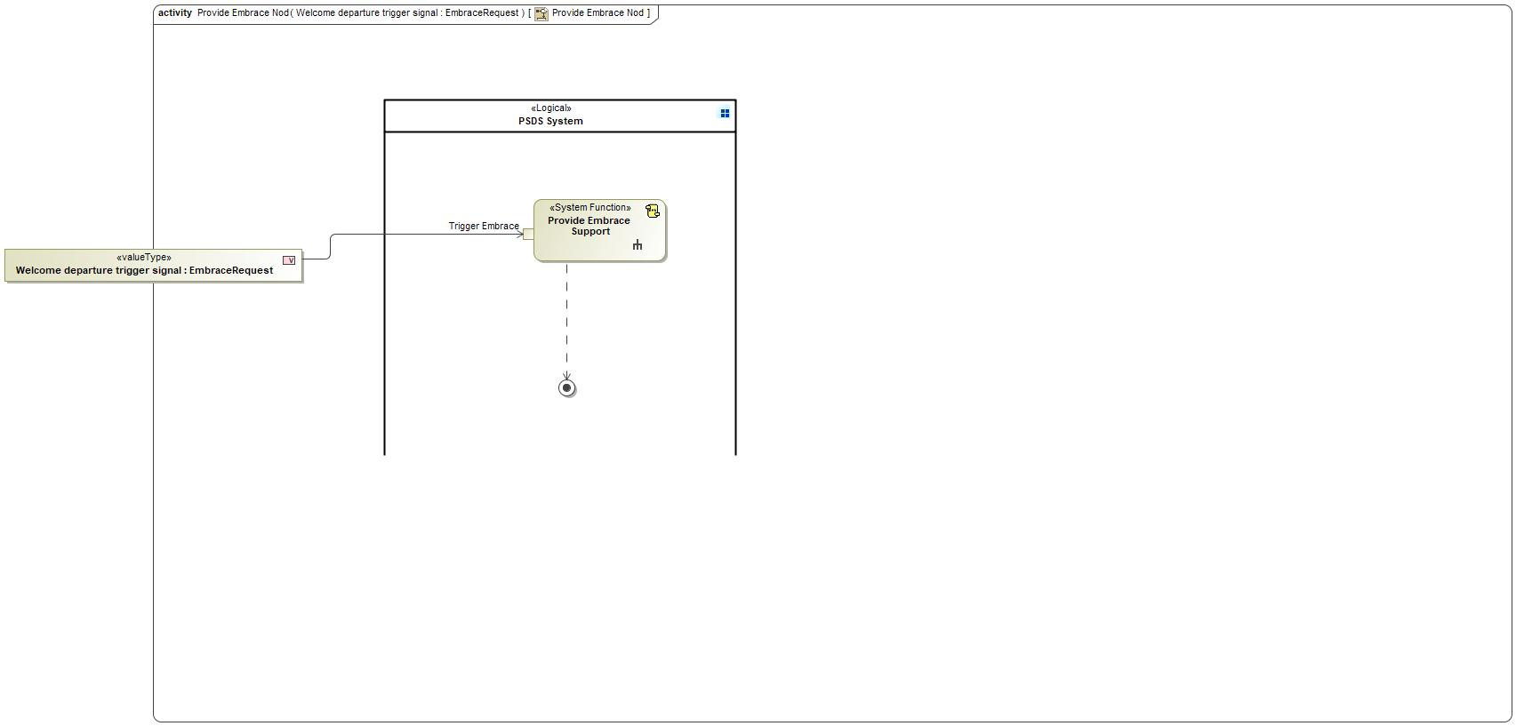

Figure 17: Activity Diagram of -830053584.jpg “Provide Embrace Nod” calling 1864100599.jpg “Provide Embrace Support”

### Function Interfaces

#### Logical Inputs

|  |  |
| --- | --- |
| **Signal Name** | **Description** |
| Trigger Embrace  Type:  746038487.jpg EmbraceRequest | Received from:   * 198874124.jpg Activity Parameter Node: Welcome departure trigger signal |

#### Logical Outputs

No Logical Outputs specified.

#### Logical Parameters

*Not supported by MagicDraw report generation.*

### Function Modeling

#### Use Cases

*Not supported by MagicDraw report generation.*

#### State Charts / Activity Diagrams / Sequence Diagrams / Decision Tables



Figure 18: Provide Embrace Support

### Function Requirements

#### Functional Requirements

##### Normal Operation

Support Embrace Experience

When the "Provide Embrace Support" receives the trigger EmbraceRequest= EMBRACE_APPROACH or EmbraceRequest=EMBRACE_DEPART it shall provide embrace support accordingly

|  |  |  |  |  |  |  |  |
| --- | --- | --- | --- | --- | --- | --- | --- |
| Requirement ID: | | | | | | | |
| **Rationale** |  | | | | | | |
| **Acceptance Criteria** |  | | | | | | |
| **Notes** |  | | | | | | |
| **Source** |  | | | | | **Owner** |  |
| **Source Req.** | * -145572143.jpg PSDS signal input * -145572143.jpg PSDS W/F/Embrace * -145572143.jpg PDLC translucent * -145572143.jpg PSDS integrated features * -145572143.jpg PDLC opaque | | | | | **V&V Method** |  |
| **Type** |  | | | **Priority** |  | **Status** |  |
| [Req. Template](http://wiki.ford.com/display/RequirementsEngineering/Requirements+Attributes) Version | | 6.0 | End of Requirement | | | | |

##### Error Handling

No Error Handling Requirements specified.

#### Non-Functional Requirements

No Non-Functional Requirements specified.

#### Functional Safety Requirements

No Functional Safety Requirements specified.

##### ASIL Decomposition of Functional Safety Requirements

No Functional Safety Requirements with ASIL Decompositions specified.

#### Other Requirements

##### Design Requirements

No Design Requirements specified.

## -588598805.jpg Provide PDLC Status

### Function Overview

#### Description

Function is allocated to:

* -1034039988.jpg Display PSDS Functionality <<Logical>>
* -1034039988.jpg Manage CAN communication <<Logical>>
* 928225610.jpg PSDS Controller <<Logical>>

No description provided for this function.

#### Variants

*Not supported by MagicDraw report generation.*

#### Input Requirements

*Not supported by MagicDraw report generation.*

#### Assumptions

No assumptions specified for this function.

#### References

##### Ford Documents

List here all Ford internal documents, which are directly related to the feature.

| **Reference** | **Title** | **Doc. ID** | **Revision** |
| --- | --- | --- | --- |
|  |  |  |  |

Table 21: Ford internal Documents *(not specified in model)*

##### External Documents and Publications

The list of external documents could include books, reports and online sources.

| **Reference** | **Document / Publication** |
| --- | --- |
|  |  |

Table 22: External documents and publications *(not specified in model)*

#### Glossary

See Appendix for Definitions and Abbreviations.

### Function Scope

The -588598805.jpg **– “Provide PDLC Status”** function is called by the following functions:

* 1864100599.jpg – “Manage Automatic PSDS Functionality”
* 1864100599.jpg – “Manage Manual PSDS Functionality”



Figure 19: Activity Diagram of 1864100599.jpg “Manage Automatic PSDS Functionality” calling -588598805.jpg “Provide PDLC Status”



Figure 20: Activity Diagram of 1864100599.jpg “Manage Manual PSDS Functionality” calling -588598805.jpg “Provide PDLC Status”

### Function Interfaces

#### Logical Inputs

|  |  |
| --- | --- |
| **Signal Name** | **Description** |
| PDLC Zone Status  Type:  746038487.jpg PDLC Zone Status | Received from:   * -588598805.jpg Sense PDLC Status |

#### Logical Outputs

|  |  |
| --- | --- |
| **Signal Name** | **Description** |
| PDLCZoneStatus  Type:  746038487.jpg PDLC Zone Status | Sent to:   * 198874124.jpg Activity Parameter Node: PDLCZoneStatus * 198874124.jpg Activity Parameter Node: PDLC Zone Status |

#### Logical Parameters

*Not supported by MagicDraw report generation.*

### Function Modeling

#### Use Cases

*Not supported by MagicDraw report generation.*

#### State Charts / Activity Diagrams / Sequence Diagrams / Decision Tables

No diagrams internal to function specified.

### Function Requirements

#### Functional Requirements

##### Normal Operation

Control PDLC Status

When "Provide PDLC Status" receives "PDLC Zone Status" it shall output "PDLC Zone Status"

|  |  |  |  |  |  |  |  |
| --- | --- | --- | --- | --- | --- | --- | --- |
| Requirement ID: | | | | | | | |
| **Rationale** |  | | | | | | |
| **Acceptance Criteria** |  | | | | | | |
| **Notes** |  | | | | | | |
| **Source** |  | | | | | **Owner** |  |
| **Source Req.** |  | | | | | **V&V Method** |  |
| **Type** |  | | | **Priority** |  | **Status** |  |
| [Req. Template](http://wiki.ford.com/display/RequirementsEngineering/Requirements+Attributes) Version | | 6.0 | End of Requirement | | | | |

##### Error Handling

No Error Handling Requirements specified.

#### Non-Functional Requirements

No Non-Functional Requirements specified.

#### Functional Safety Requirements

No Functional Safety Requirements specified.

##### ASIL Decomposition of Functional Safety Requirements

No Functional Safety Requirements with ASIL Decompositions specified.

#### Other Requirements

##### Design Requirements

No Design Requirements specified.

## -588598805.jpg Sense PDLC Status

### Function Overview

#### Description

Function is allocated to:

* -1034039988.jpg PDLC Sensing Status <<Logical>>
* 928225610.jpg PDLC Sensor <<Logical>>

No description provided for this function.

#### Variants

*Not supported by MagicDraw report generation.*

#### Input Requirements

*Not supported by MagicDraw report generation.*

#### Assumptions

No assumptions specified for this function.

#### References

##### Ford Documents

List here all Ford internal documents, which are directly related to the feature.

| **Reference** | **Title** | **Doc. ID** | **Revision** |
| --- | --- | --- | --- |
|  |  |  |  |

Table 23: Ford internal Documents *(not specified in model)*

##### External Documents and Publications

The list of external documents could include books, reports and online sources.

| **Reference** | **Document / Publication** |
| --- | --- |
|  |  |

Table 24: External documents and publications *(not specified in model)*

#### Glossary

See Appendix for Definitions and Abbreviations.

### Function Scope

The -588598805.jpg **– “Sense PDLC Status”** function is called by the following functions:

* 1864100599.jpg – “Manage Automatic PSDS Functionality”
* 1864100599.jpg – “Manage Manual PSDS Functionality”
* 120325397.jpg – “PSDS Welcoming Lincoln Owner”



Figure 21: Activity Diagram of 1864100599.jpg “Manage Automatic PSDS Functionality” calling -588598805.jpg “Sense PDLC Status”



Figure 22: Activity Diagram of 1864100599.jpg “Manage Manual PSDS Functionality” calling -588598805.jpg “Sense PDLC Status”



Figure 23: Activity Diagram of 120325397.jpg “PSDS Welcoming Lincoln Owner” calling -588598805.jpg “Sense PDLC Status”

### Function Interfaces

#### Logical Inputs

|  |  |
| --- | --- |
| **Signal Name** | **Description** |
| Physical Status Signal  Type:  746038487.jpg PDLC Physical Measured Position | Received from:   * -588598805.jpg Actuate PDLC |

#### Logical Outputs

|  |  |
| --- | --- |
| **Signal Name** | **Description** |
| PDLC Zone Status  Type:  746038487.jpg PDLC Zone Status | Sent to:   * -588598805.jpg Provide PDLC Status |

#### Logical Parameters

*Not supported by MagicDraw report generation.*

### Function Modeling

#### Use Cases

*Not supported by MagicDraw report generation.*

#### State Charts / Activity Diagrams / Sequence Diagrams / Decision Tables

No diagrams internal to function specified.

### Function Requirements

#### Functional Requirements

##### Normal Operation

Control PDLC Sensing

When "Sense PDLC Status" receives "PDLC Physical Measured Position" it shall output "PDLC Zone Status"

|  |  |  |  |  |  |  |  |
| --- | --- | --- | --- | --- | --- | --- | --- |
| Requirement ID: | | | | | | | |
| **Rationale** |  | | | | | | |
| **Acceptance Criteria** |  | | | | | | |
| **Notes** |  | | | | | | |
| **Source** |  | | | | | **Owner** |  |
| **Source Req.** |  | | | | | **V&V Method** |  |
| **Type** |  | | | **Priority** |  | **Status** |  |
| [Req. Template](http://wiki.ford.com/display/RequirementsEngineering/Requirements+Attributes) Version | | 6.0 | End of Requirement | | | | |

##### Error Handling

No Error Handling Requirements specified.

#### Non-Functional Requirements

No Non-Functional Requirements specified.

#### Functional Safety Requirements

No Functional Safety Requirements specified.

##### ASIL Decomposition of Functional Safety Requirements

No Functional Safety Requirements with ASIL Decompositions specified.

#### Other Requirements

##### Design Requirements

No Design Requirements specified.

# Open Concerns

**#Hint:** The following list presents open concerns, which have to be discussed or clarified over the course of the on-going requirements engineering.

| ID | Concern Description | e-Tracker / Reference | Responsible | Status | Solution |
| --- | --- | --- | --- | --- | --- |
| 1 |  |  |  |  |  |

Table 25: Open Concerns *(Not supported by MagicDraw report generation.)*

# Revision History

**#Hint:** A new version number is assigned to a document with a given revision each time it is checked in to Team Center (TCSE). After release of a revision, the document cannot be edited and no new versions can be created on that revision. When updating the document after that, a new revision has to be created and new versions on that revision will be created upon checking in.

No Revision History found.

## Template Revisions

*#Important: Do not change this section*

|  |  |  |  |  |
| --- | --- | --- | --- | --- |
| Version | Rev. | Date | Description | Responsible |
| *1* | *0* | *2016-02-26* | *Initial version, derived from FDS* | *Jbaden1* |
| *1* | *1* | *2016-02-26* | *Word properties corrected* | *Jbaden1* |
| *1* | *2* | *2016-03-10* | *Clean up of document meta data (Word properties)* | *Jbaden1* |
| *1* | *3* | *2016-03-22* | * *Footer formatting corrected (Issue 19)* * *“Constraints” chapter renamed to “Input Requirements” (Issue 20)* | *Jbaden1* |
| *1* | *4* | *2016-04-20* | * *Broken Wiki links repaired* | *Jbaden1* |
| *2* | *0* | *2016-06-10* | * *Document metadata adapted. Prepared for new macros* * *DTC table removed* * *HMI function added as a chapter (details still to be refined)* * *Signal / Parameter IDs column deleted interface tables* | *Jbaden1* |
| *2* | *1* | *2016-07-14* | * *Converted to SysML diagrams* * *HMI section further elaborated* * *Template version added to footer* * *Dedicated Startup / Shutdown sections removed (only hints added)* * *Data Dictionary reworked and Signal / Parameter IDs column re-introduced* | *Jbaden1* |
| *2* | *2* | *2016-12-07* | * *Minor formatting changes* | *Jbaden1* |
| *3* |  |  | *Skipped to synchronize with Specification_Macros.dotm* |  |
| *4* |  |
| *5* | *0* | *2017-01-13* | * *Meta data updated for specification macros, version 3.1* * *SW Unit chapter removed for the time being* * *Green boxes added for user hints* | *Jbaden1* |
| *5* | *1* | *2017-01-18* | * *Some additional hints.* * *Hyperlinks highlighted in hints* | *Jbaden1* |
| *6* | *0* | *2017-04-28* | * *Editorial change. Hints added to chapter 4.1.4* * *Chapter “Traceability Matrix” removed* | *Jbaden1* |
| *6* | *0* | *2018-04-28* | * *CR69/63: New chapters added for Functional Safety (FTTI and Technical Safety Requirements)* * *CR53: New coversheet + additional meta-data* * *CR76: merge sections for configuration and for calibration parameters into one on Function Level* | *Jbaden1* |
| *6* | *0* | *2018-08-06* | * *CR66: Fix version numbering in footer of Function Spec* | *Jbaden1* |
| *6* | *0* | *2018-09-28* | * *Broken links to RE Wiki repaired* | *Jbaden1* |
| *6* | *0* | *2018-10-31* | * *Minor corrections on cover sheet and in footer to be more GIS compliant and VSEM aligned* * *“Overview” and “Description” exchanged in headings (following common sense)* | *Jbaden1* |
| *6* | *0* | *2018-11-12* | * *Explanatory text in Variants” section revised* * *Functional Safety modifications as agreed with FuSa core team (Baseline: November 2018 Dearborn On-Site)* | *Jbaden1* |
| *M* |  | *2019-04-02* | * *Initial version of SysML report template* | *snuesch* |
| *M* |  | *2019-04-05* | * *Improved dialog boxes to select function group* | *snuesch* |
| *M* |  | *2019-04-26* | * *Improved function interfaces (support of additional elements (e.g., send signal action, add structural feature action, merge node, decision node, activity parameter nodes, etc.) and pins)* | *snuesch* |
| *N* |  | *2019-08-19* | * *For each function now also requirements satisfied by activity parameter nodes and function outputs are populated.* | *snuesch* |
| *N* |  | *2019-08-21* | * *Improved glossary and acronym tables* | *snuesch* |
| *N* |  | *2019-09-20* | * *Updated Function Interfaces tables with better wording. Added a report template variable that allows to disable senders and receivers. Sorted requirements by ID.* | *snuesch* |
| *N* |  | *2019-09-27* | * *Green hints now only show up for first function.* * *labelTag variable can be used to filter revision history.* | *snuesch* |

# Appendix

## Data Dictionary

### Logical Signals

**#Macro:** [Add Ins -> Add Requirement macro](http://wiki.ford.com/display/RequirementsEngineering/Adding+a+Logical+Signal+or+Parameter) (select “Logical Signal” as type)

Ambient Temperature

|  |  |  |
| --- | --- | --- |
| **ASIL** | |  |
| **Encoding Type Name** | |  |
| Note: An encoding is either discrete or continuous. Delete fields below which are not needed | | |
| **Value**  (Continuous Encoding) | Min Value |  |
| Max Value |  |
| Resolution |  |
| Offset |  |
| **Value**  (Discrete  Encoding) |  |  |
| **Unit** | |  |

BatterySOC_Status

|  |  |  |
| --- | --- | --- |
| **ASIL** | |  |
| **Encoding Type Name** | |  |
| Note: An encoding is either discrete or continuous. Delete fields below which are not needed | | |
| **Value**  (Continuous Encoding) | Min Value |  |
| Max Value |  |
| Resolution |  |
| Offset |  |
| **Value**  (Discrete  Encoding) |  |  |
| **Unit** | |  |

Cabin Temperature

|  |  |  |
| --- | --- | --- |
| **ASIL** | |  |
| **Encoding Type Name** | |  |
| Note: An encoding is either discrete or continuous. Delete fields below which are not needed | | |
| **Value**  (Continuous Encoding) | Min Value |  |
| Max Value |  |
| Resolution |  |
| Offset |  |
| **Value**  (Discrete  Encoding) |  |  |
| **Unit** | |  |

Crash_Event

|  |  |  |
| --- | --- | --- |
| **ASIL** | |  |
| **Encoding Type Name** | |  |
| Note: An encoding is either discrete or continuous. Delete fields below which are not needed | | |
| **Value**  (Continuous Encoding) | Min Value |  |
| Max Value |  |
| Resolution |  |
| Offset |  |
| **Value**  (Discrete  Encoding) |  |  |
| **Unit** | |  |

EmbraceRequest

|  |  |  |
| --- | --- | --- |
| **ASIL** | |  |
| **Encoding Type Name** | |  |
| Note: An encoding is either discrete or continuous. Delete fields below which are not needed | | |
| **Value**  (Continuous Encoding) | Min Value |  |
| Max Value |  |
| Resolution |  |
| Offset |  |
| **Value**  (Discrete  Encoding) |  |  |
| **Unit** | |  |

IgnitionStatus

|  |  |  |
| --- | --- | --- |
| **ASIL** | |  |
| **Encoding Type Name** | |  |
| Note: An encoding is either discrete or continuous. Delete fields below which are not needed | | |
| **Value**  (Continuous Encoding) | Min Value |  |
| Max Value |  |
| Resolution |  |
| Offset |  |
| **Value**  (Discrete  Encoding) |  |  |
| **Unit** | |  |

OperationStatus

|  |  |  |
| --- | --- | --- |
| **ASIL** | |  |
| **Encoding Type Name** | |  |
| Note: An encoding is either discrete or continuous. Delete fields below which are not needed | | |
| **Value**  (Continuous Encoding) | Min Value |  |
| Max Value |  |
| Resolution |  |
| Offset |  |
| **Value**  (Discrete  Encoding) |  |  |
| **Unit** | |  |

PDLC Actuate Command

|  |  |  |
| --- | --- | --- |
| **ASIL** | |  |
| **Encoding Type Name** | |  |
| Note: An encoding is either discrete or continuous. Delete fields below which are not needed | | |
| **Value**  (Continuous Encoding) | Min Value |  |
| Max Value |  |
| Resolution |  |
| Offset |  |
| **Value**  (Discrete  Encoding) |  |  |
| **Unit** | |  |

PDLC Physical Measured Position

|  |  |  |
| --- | --- | --- |
| **ASIL** | |  |
| **Encoding Type Name** | |  |
| Note: An encoding is either discrete or continuous. Delete fields below which are not needed | | |
| **Value**  (Continuous Encoding) | Min Value |  |
| Max Value |  |
| Resolution |  |
| Offset |  |
| **Value**  (Discrete  Encoding) |  |  |
| **Unit** | |  |

PDLC Request

|  |  |  |
| --- | --- | --- |
| **ASIL** | |  |
| **Encoding Type Name** | |  |
| Note: An encoding is either discrete or continuous. Delete fields below which are not needed | | |
| **Value**  (Continuous Encoding) | Min Value |  |
| Max Value |  |
| Resolution |  |
| Offset |  |
| **Value**  (Discrete  Encoding) |  |  |
| **Unit** | |  |

PDLC Zone Status

|  |  |  |
| --- | --- | --- |
| **ASIL** | |  |
| **Encoding Type Name** | |  |
| Note: An encoding is either discrete or continuous. Delete fields below which are not needed | | |
| **Value**  (Continuous Encoding) | Min Value |  |
| Max Value |  |
| Resolution |  |
| Offset |  |
| **Value**  (Discrete  Encoding) |  |  |
| **Unit** | |  |

PSDSMode

|  |  |  |
| --- | --- | --- |
| **ASIL** | |  |
| **Encoding Type Name** | |  |
| Note: An encoding is either discrete or continuous. Delete fields below which are not needed | | |
| **Value**  (Continuous Encoding) | Min Value |  |
| Max Value |  |
| Resolution |  |
| Offset |  |
| **Value**  (Discrete  Encoding) |  |  |
| **Unit** | |  |

RejuvenateRequest

|  |  |  |
| --- | --- | --- |
| **ASIL** | |  |
| **Encoding Type Name** | |  |
| Note: An encoding is either discrete or continuous. Delete fields below which are not needed | | |
| **Value**  (Continuous Encoding) | Min Value |  |
| Max Value |  |
| Resolution |  |
| Offset |  |
| **Value**  (Discrete  Encoding) |  |  |
| **Unit** | |  |

ShedLevelRequest

|  |  |  |
| --- | --- | --- |
| **ASIL** | |  |
| **Encoding Type Name** | |  |
| Note: An encoding is either discrete or continuous. Delete fields below which are not needed | | |
| **Value**  (Continuous Encoding) | Min Value |  |
| Max Value |  |
| Resolution |  |
| Offset |  |
| **Value**  (Discrete  Encoding) |  |  |
| **Unit** | |  |

Sun Load Status

|  |  |  |
| --- | --- | --- |
| **ASIL** | |  |
| **Encoding Type Name** | |  |
| Note: An encoding is either discrete or continuous. Delete fields below which are not needed | | |
| **Value**  (Continuous Encoding) | Min Value |  |
| Max Value |  |
| Resolution |  |
| Offset |  |
| **Value**  (Discrete  Encoding) |  |  |
| **Unit** | |  |

Sun Location Status

|  |  |  |
| --- | --- | --- |
| **ASIL** | |  |
| **Encoding Type Name** | |  |
| Note: An encoding is either discrete or continuous. Delete fields below which are not needed | | |
| **Value**  (Continuous Encoding) | Min Value |  |
| Max Value |  |
| Resolution |  |
| Offset |  |
| **Value**  (Discrete  Encoding) |  |  |
| **Unit** | |  |

VisualGlassStatus

|  |  |  |
| --- | --- | --- |
| **ASIL** | |  |
| **Encoding Type Name** | |  |
| Note: An encoding is either discrete or continuous. Delete fields below which are not needed | | |
| **Value**  (Continuous Encoding) | Min Value |  |
| Max Value |  |
| Resolution |  |
| Offset |  |
| **Value**  (Discrete  Encoding) |  |  |
| **Unit** | |  |

### Logical Parameters

**#Macro:** [Add Ins -> Add Requirement macro](http://wiki.ford.com/display/RequirementsEngineering/Adding+a+Logical+Signal+or+Parameter) (select “Logical Parameter” as type)

### Encoding Types

**#Macro:** [Add Ins -> Add Requirement macro](http://wiki.ford.com/display/RequirementsEngineering/Adding+an+Encoding+Type) (select “Encoding Type” as type)

## Glossary

**#Hint**: Terms, concepts and abbreviations used in the document shall be defined and illustrated here. Note that changes to terms and/or concepts described in this section tend to cause major updates to this document.

The tables below have feature specific definitions and abbreviations. For additional, non-feature specific terms please refer to the [RE Glossary](http://wiki.ford.com/display/RequirementsEngineering/Glossary?src=contextnavpagetreemode)

### Definitions

**#Hint:** The table below has definitions and abbreviations relevant for the functions in this document. For additional terms please refer to the [RE Glossary](http://wiki.ford.com/display/RequirementsEngineering/Glossary?src=contextnavpagetreemode)

No terms specified.

### Abbreviations

No acronyms specified.

Document ends here.